***Zomato Restaurant Data Analysis***



**Objective:**

To analyse the data and come up with some useful insights to open a new restaurant.

**Objective Questions:**

Each question is answered and Point of view is also mentioned.

**Que1**- **What is the total no. of tables present in the table?**

**Ans1**- There are two tables in the given excel workbook one is present in the sheet named ***Raw Data*** which contains details of the restaurants and second is present in sheet named ***Country Description*** which contains details regarding countries and country codes.

**Point of View**: I simply look at the workbook and come to know about the tables present in the data.

**Que2**- **What is the total no. of attributes present in the data?**

**Ans2**- There are 20 columns present in the sheet named ***Raw Data*** and 2 columns present in the sheet named ***Country Description***.

**Point of View**: I simply count the columns in both the sheets.

**Que3**- **How many categorical columns are there in the data?**

**Ans3**- 19 Categorical columns in the data.

**Point of View**- Categorical are those columns those which have finite values and can be further divided into category.

1. Restaurant

2. Restaurant Name

3. Country Code

4. Country

5. City

6. Address

7. Locality

8. Locality Verbose

9. Cuisines

10. Currency

11. Has Table booking

12. Has Online delivery

13. Is delivering now

14. Switch to order menu

15. Price range

16. Votes

17. Average Cost for 2

18. Rating

19. Year

**Que4**- **The data consists of some inconsistent and missing values so ensure that the data used for further analysis is cleaned.**

**Ans4**- Yes data had some missing value and inconsistency. I rectified them.

Point of View: First of all, I put the count blank formula at the end of each column to check if is there any blank cells in the columns and I found that there are 9 blanks in the column named Cuisines and filled those columns according the country code of the restaurants. After that I found that 0 is present in the column names **Longitude, Latitude and Votes**, then I checked the average of all the columns and I replace all the Zeros with the **average of the particular column respectively**. I created new column named as year and use remove duplicates in whole data but no duplicates were found.

**Que5**- **Using the Lookup functions, fill up the countries in the original data using the country code.**

**Ans5**- I used VLOOKUP function to fill up the countries.

**Point of View**- I have created a new column named country in the ***Raw Data*** sheet and used VLOOKUP function [VLOOKUP (C2,'country description'!$A$1:$B$16,2,0) ] after using this formula I got the country name and later on I used fill down button fill all country names.

**Que6**- **Create a table to represent the number of restaurants opened in each country.**

**Ans6**- There are two ways to do this **1. Use Count if formula, 2. Use Pivot table**.

**Point of View**- I solved this question with both ways, I solved this question by created new column No. of Restaurants in sheet name ***Country description*** in the workbook.

I have pasted the screenshot of both the methods below please use for the reference.

**Below screenshots are taken from the excel sheet names Country Description.**

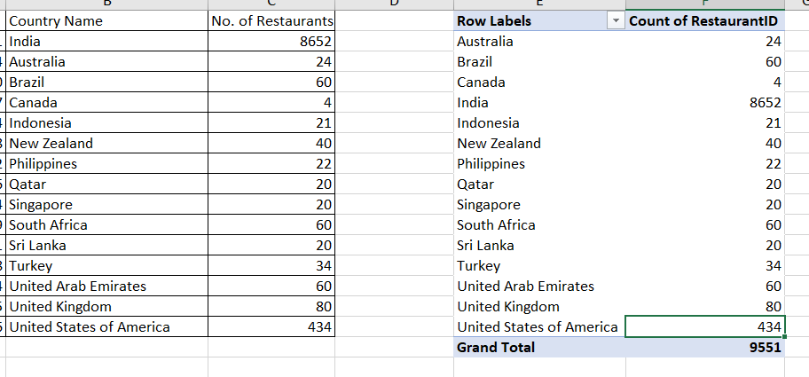

**Que7**- **Also, the management wants to look at the number of restaurants opened each year, so provide them with something here.**

**Ans7**- I used Pivot Table for this answer in the sheet named Year.

**Point of View**- I solved this question with the help of Pivot Table and also pasted the screenshot below for the reference.

**Below screenshots are taken from the excel sheet name Year.**

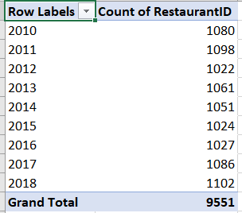

**Que8**- **What is the total number of restaurants in India in the price range of 4?**

**Ans8**- There are two ways to solve this question **1 Countifs, 2 Pivot Table**.

**Point of View**- I solved this question by both of the methods in the sheet named **Price Range**. Also pasting the screenshot below for the reference.

**Below screenshots are taken from the excel sheet name Price Range.**

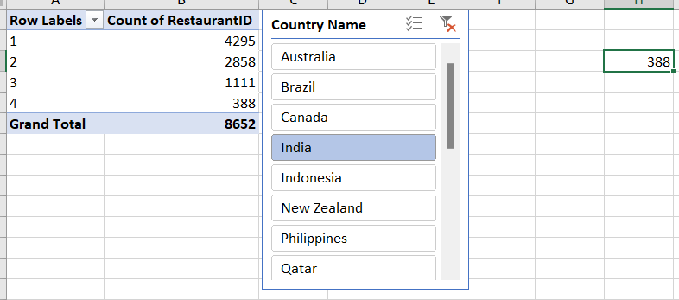

**Que9**- **What is the average number of voters for the restaurants in each country according to the data?**

**Ans9**- For this question we have to make another Pivot Table. But before that I am replacing the 0 with average of the votes i.e. 156.91, so that data should be correct.

**Point of View**- I solved this question by Pivot Table in the sheet named as **Votes** and pasted the screenshot below for the reference.

**Below screenshots are taken from the excel sheet name Votes.**

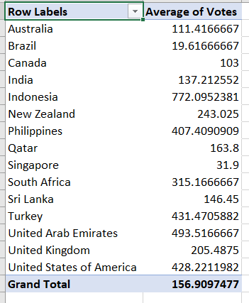

**Que10**- **Calculate the average rating for all the restaurants that have price_range < 4 and provide online delivery.**

**Ans10**- The average rating for all restaurants that have price_range < 4 and provide online delivery is 3.273812.

**Point of View**- I have used nested if here along with array function in the sheet named as ***Country Description***, formula is pasted below for the reference {=AVERAGE(IF(('Raw Data'!P2:P9552<4)*('Raw Data'!M2:M9552="Yes"),'Raw Data'!S2:S9552)) }

**Que11**- **Using Conditional formatting highlight the rows of restaurants that are located in the countries or cities that you’ve suggested to the management for opening new restaurants.**

**Ans11-** All countries are highlighted.

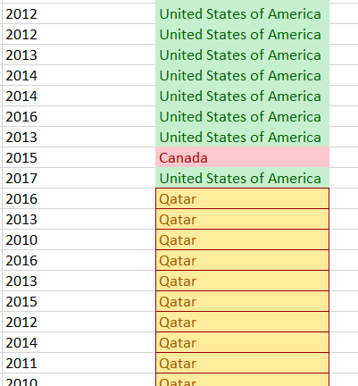**Point of View**- I used conditional formatting and highlighted the countries on the basis of online delivery, Number of restaurants, Price range and Average votes. Screenshot is pasted below for the reference.

**Que12 - Create a new customized price column that consists of the abbreviation/symbol of the currency along with the Average_cost_for_two value**.

**Ans12-** I used TRIM function along with MID and FIND function in the new column created named as ***Updated Cost with Abvr***.

**Point of View** - =TRIM(MID(K2,FIND("(",K2)+1,FIND(")",K2)-FIND("(",K2)-1))&R2

**Below screenshots are taken from the excel sheet name Raw Data.**

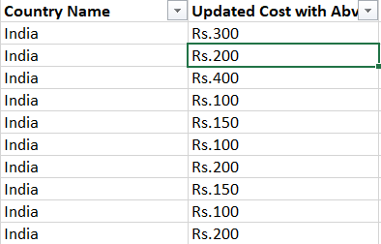

**Que13 How can you create an array formula in Excel or Google Sheets to count the number of restaurants listed that do not offer online delivery, are in the lowest price range, and have an average cost for two people less than or equal to 250 Indian Rupees?**

**Ans13** The number of restaurants which do not offers online delivery and have the lowest price range and have in average cost of two people less than or equals to 250 in the country India are 1694 by using the array function.

**Point of View** To solve this question I have converted the average cost for two which is in different currencies for different countries into rupees and then I have used the array formula.

Formula used: {SUM(IF((('Raw Data'!P2:P9552=1)*('Raw Data'!M2:M9552="No")*('Raw Data'!S2:S9552<=250)),1,0))}

In the above formula P represents Price range, M represents Has online delivery, S represents Currency updated.

**Below screenshot is taken from the excel sheet name Country Description.**

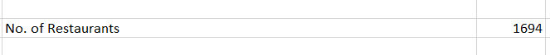

The value 1694 is present in cell number J7 in sheet named country description.

**Subjective Questions:**

**Que1 Suggest a few countries where the team can open newer restaurants with lesser competition. Which visualization/technique will you use here to justify the suggestions?**

**Ans1** I suggested three countries for opening the new restaurants based on No. of restaurants already present there, average of votes, based on types of deliveries and price range.

1. **Canada**
2. **Qatar**
3. **United States of America**

**Insights and Suggestions:**

● **Canada** have only 4 restaurants. These numbers are significantly lower than in other countries, such as India, where there are over 8,600 restaurants. The average ratings for Canada is reasonably high at 3.575, indicating a market with potential for growth.

● **Qatar** have 20 restaurants with an average rating of 4.06, This suggests that while there is some competition, the market is not saturated, leaving room for new entries.

● **United States of America** have 434 restaurants with an average rating of 4.01, reflecting a balance between online and table bookings and relatively high customer satisfaction.

**Below charts are taken from the excel sheet names all pivots and charts.**

**Que2 Come up with the names of States and cities in the suggested countries suitable for opening restaurants.**

**Ans2** I suggested 5 cities in which new restaurants can be open on based on the numbers of the restaurants were already present there and ratings.

1. **Potrero**
2. **Miller**
3. **Cochrane**
4. **Consort**
5. **Doha**

**Insights and Suggestions:**

● **Cochrane** have only 1 restaurant. This suggests that competition is low there and having average rating of 3.1 reflecting that there is opportunity for new restaurants.

● **Consort** has only one restaurant, making it an ideal location with minimal competition. The average rating of 3 suggests room for improvement, offering an opportunity to introduce new dining experiences.

● **Doha** While Singapore has 20 restaurants, the consistent average rating of 4.06 this is higher than the average of the market.

● **Miller** has 1 restaurant, the consistent average rating of 3.4 indicates steady demand. This presents an opportunity for new entrants to differentiate themselves with unique offerings.

● **Potrero** has only one restaurant with a low moderate rating of 3.3, This creates an opportunity for a new restaurant to capture the market by offering a superior dining experience.

**Below chart is taken from excel sheet named All Pivots and Charts**

**Que3 According to the countries you suggested, what is the current quality regarding ratings for restaurants that are open there?**

**Ans3 Approach:**

The Countries which I have selected for opening the new restaurants has current quality of average rating is more than 4, also have less number of restaurants already present there.

**Insights:**

1. Canada has an average rating of 3.5. Qatar with 4.06 ratings. United States of America has an average rating of 4.0.
2. Qatar and United states of America has wide difference in the number of hotels but rating for both countries are similar.

**Recommendation:**

1. Get the average rating of each restaurants to understood the rating like rating is good or not but in the above countries restaurants are good rating so its good if open in new restaurants in above country.

**Below screenshot is taken from excel sheet named All Pivots and Charts**

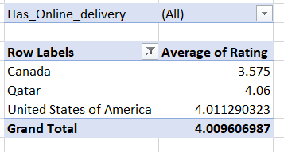

**Que4 Also, what is the current expenditure on food in the suggested countries, so we can keep our financial expenditure in control?**

**Ans4 Approach:** To answer the above question we have to check average cost of 2 people in suggested countries and the currency would be in same manner, so for that I converted all currencies into Indian Rupees so that we can compare easily and fairly.

1. Average cost in Canada = Rs.3045
2. Average cost in Qatar = Rs.5146.25
3. Average cost in United States of America = 2196.77

**Insights:**

1. Canada having only 4 restaurants with an average cost of 3045INR, indicates a good opportunity for growth because of low competition and an economical pricing.
2. Qatar is having the highest average cost in the above suggested countries.
3. United States of America has the lowest average cost among the suggested countries. This may indicate that people are more budget-conscious.

**Recommendation:**

1. Canada shows a significant opportunity for new restaurants because of the less competitive market along with economical expenditure. Expanding here will give us a strong opportunity to capture a good customer base.
2. In Qatar, people are willing to spend more. Offering good quality of food and services will further help improving the customer relations. As mentioned before, offering cuisine specific restaurant with a high focus on quality of food and a good dining experience will gain us a good advantage to capture the market despite the high competition.
3. As customers are more budget conscious in United States of America, focus on budget friendly restaurant is essential. Offering discounts or combo deals may help in attracting more customers.

**Below chart is taken from excel sheet named All Pivots and Charts**

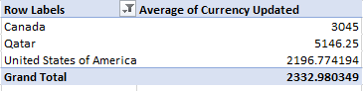

**Que5 Come up with the names of restaurants from the recommended states that are our biggest competitors and also those that are rated in the lower brackets, i.e. 1-2 or 2-3.**

**Ans5 Approach:** Here our biggest competitors are those restaurants which have rating more than 4, so for that I created the Pivot table which shows restaurants names which have rating more than 4 as well as rating under the bracket of 1-2,2-3.

**Insights:**

1. In the below data of these restaurants name for good competitor in the market.

**Recommendation:**

1. Doha has the highest number of restaurants rating above 4. There is no single restaurant which has the lowest rated restaurants among the suggested countries. This indicates that there is a clientele that is willing to spend on restaurants. Focus on providing a quality and unique experience will definitely help capture a larger market and improve the average cost.

**Below chart is taken from excel sheet named All Pivots and Charts**

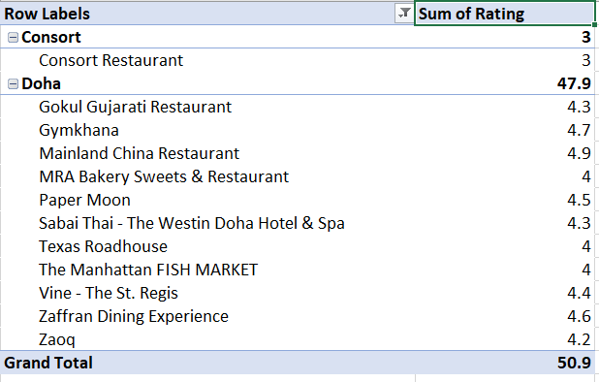

I also created 3D column chart to visualize the above in the pictorial form.

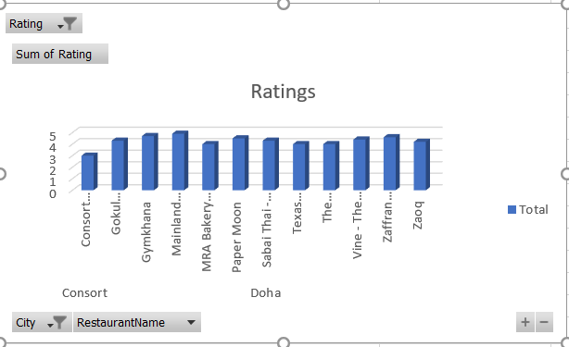

**Que6 Which cuisines should we focus on in the newer restaurants to get better feedback? Does the choice of cuisines affect the restaurant ratings?**

**Ans6 Approach:** Yes, Cuisines will definitely affect the restaurants ratings, because each city has different cuisines liked in different areas, for this I created the Pivot table. Through pivot table we can understand easily the restaurants, cuisines and their rating as well. Like Cochrane city has cuisines Asian and Japanese which have ratings more than 3, likewise Doha city have ,ore types of cuisines liked in different areas of the cities. Indian, Italian and Chinese are having ratings more than 4 and so on.

**Insights:**

1. Restaurant in Cochrane and Consort serving Asian, Chinese, Canadian and Japanese cuisine are only receiving average ratings.
2. Doha is receiving average ratings in almost all the cuisines available.

**Recommendation:**

1. In Cochrane, Chinese and Canadian cuisine are rated low. Focus in providing authentic Chinese cuisine with a unique dining experience will help capture the market.
2. Similarly, Consort is rating average in all global cuisines. Dining experience and authentic food should be given more importance.

**Below screenshot is taken from excel sheet named All Pivots and Charts**

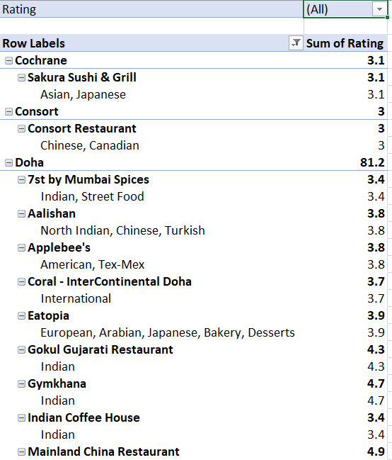

**Que7 According to our current data, should we go for online delivery and table booking? Does that affect the customer’s ratings?**

**Ans7 Approach:** Yes it affect the customer’s ratings because if we simply see at average ratings of the restaurants which have no table bookings nor online deliveries is 2.67, but if the restaurants have both online deliveries and table bookings then the average becomes 3.6.

**Insights:**

1. Restaurants with online delivery have a higher average rating compared to others. This suggests that offering online delivery services can enhance customer satisfaction and overall ratings.
2. Similarly, restaurants that provide table booking options have a higher average rating compared to those that don’t. This indicates that customers value the convenience of reserving a table.

**Recommendation:**

1. It is evident in the charts that restaurants that provide online deliveries and table bookings receive a higher rating than those that don’t.

**Please see at the Pivot tables below. All below pictures are taken from excel sheets named All Pivots and Charts.**

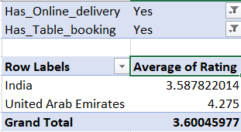 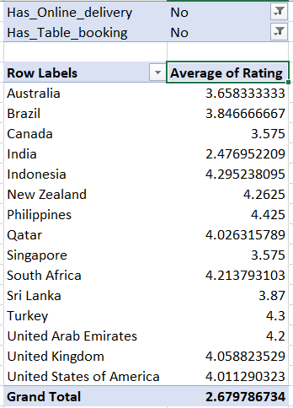

Also I pasted the different of pie charts which are showing separetly the percentage of average ratings for the resaturents has online deliveries and the restaurengts which have table bookings there are slightly a diffrence between them.

**Que8 Should the team keep the rate of cuisines higher? Will that affect the feedback? According to our data are the rates of cuisines and ratings, correlated?**

**Ans8 Approach:** The correlation between the average cost of two and the average rating is not seen to be good as the value is 0.194856293, but the correlation coefficient ranges between -1 to +1, but here our result increases the range which the correlation is not so good between rates or cuisines and ratings. Below chart and pivot table will help in understanding the correlation between both.

**Insights:**

1. Here in below pivot table it shows the correlation between average cost of two in Indian rupees and average rating.
2. Here we get the value 0.194 by using correlation formula between average cost of two and average rating which not seen to very much good.

**Recommendation:**

1. As we can see, there is no correlation between ratings and average cost of the countries.
2. High ratings can be found at various price points, this indicates that there are other factors that play a significant role in determining the ratings and customer satisfaction.

**Below chart is taken from excel sheet named All Pivots and Charts.**

**And the screenshot of value is taken from the sheet named All Pivots and Charts from cell AN26.**

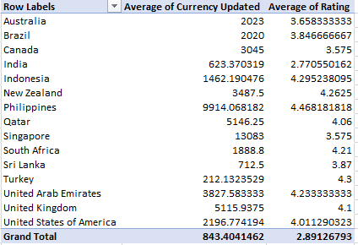

**Que9** **What is the distribution of the number of restaurants of different price ranges in all the countries?**

**Ans9 Approach:** Different countries have different number of restaurants within the different price range. Whereas India have the maximum number of the of the restaurants among all price ranges. States such as the United States, United Kingdom, and South Africa have a more balanced distribution across the different price ranges but with significantly lower totals compared to India. Countries like Indonesia, Sri Lanka, and Qatar, have minimum number of restaurants.

**Insights:**

1. As evident in the Chart, more number of the restaurants i.e. more than 4000 fall under the price range of 1. This indicates that most restaurants offer affordable dining experience.
2. And only few restaurants are in the price range of 4.
3. Number of restaurants gradually reduce as the price range increases. Which may be because of high cost.

**Recommendation:**

1. Opening restaurants in the price range of 1-2 would help us attract a large clientele since we know that majority of the market is between these ranges.
2. Opening restaurants in higher price range like 3-4 would cater to a small audience, offering unique and special dining experience with good quality food may help attract this clientele as they are willing to pay for better experience.

**Below chart is taken from excel sheet named All Pivots and Charts**

**Que10 Explain your approach in brief for suggesting countries/cities in order to open new restaurants, if the objective and subjective questions would have not been given to assist you.**

**Ans10 Country and City Selection Strategy**:

● **Low Competition**: Select countries and cities based on a strategic analysis of restaurant density. The aim is to enter markets with fewer existing restaurants to minimize direct competition and increase the chances of establishing a strong market presence.

● **Quality of Food**: Focused on cities where the average cost for two is high. This suggests a higher spending capacity among customers, which provides an opportunity to introduce affordable yet high-quality food options. By offering competitive pricing, we can attract cost-conscious customers while maintaining a focus on quality.

● **Ratings :** Approach those cities, restaurants and cuisines those which have higher ratings compare to others.

● **Way of Delivery :** Focused on those countries those have online delivery as well as table bookings because it increase the sales of the restaurants.